**Logbook Entry Window**

# Geoff Anderson G3NPA, Jim Hargrave W5IFP and Aki Yoshida JA1NLX

### 9.5. Editing QSOs in Scratchpad

**Note**: More options are checked in the setup table for following examples.

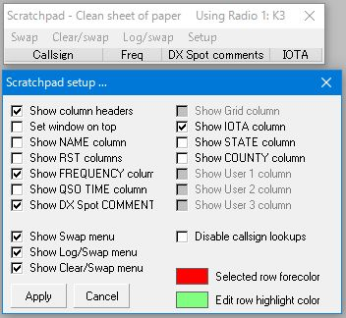

LBEW_34A

You can edit any QSO data except Freq, QSO time and DX spot comment. Right click the edit box you want to edit. In this case I want to edit IOTA with TEST2 QSO.

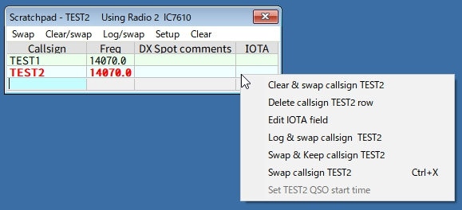

new LBEW_35

Click Edit IOTA field and enter as-007.

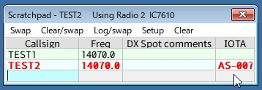

New LBEW_36

If you want to edit other fields, e.g. Test2 then select to that field (TEST2).

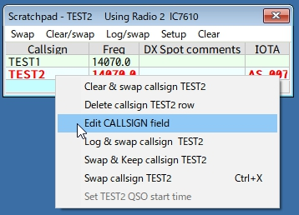

new LBEW_36A

Click Edit CALLSIGN field and type TEST3. Hit the <Enter> key.

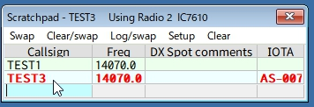

new LBEW_37

### 9.6. Tips

### 9.6.1 QSO Time

There are options to setup QSO Start time. Right click on Logbook Entry Window and click Setup.

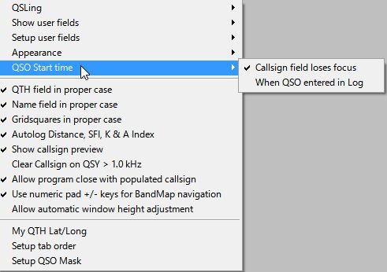

LBEW_39

If "Callsign field loses focus" is checked then you have another option to set QSO Start time in Scratchpad. Right click on any row in the Scratchpad Window. Click "Set XXX QSO start time " (XXX is the callsign) Elapsed time is displayed in QSO Time column.

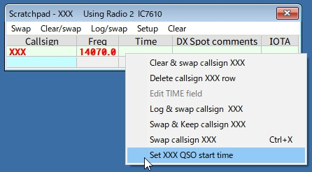

new LBEW_39A

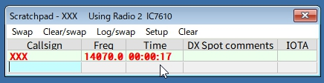

new LBEW_39B

If "When QSO entered in Log" is checked then logged TIME_ON is always same as TIME_OFF　regardless Scratchpad operation.

### 9.6.2 When You Close Logger32

You may receive the following warning message. You must close the Scratchpad first then close Logger32.

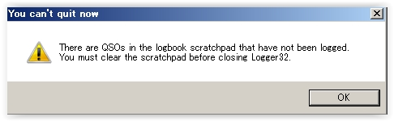

LBEW_40

### 9.6.3 Grid Appearance

To change the column order and width of the grids:

* + Drag the mouse on the border between columns to change column width; and,
  + Drag the mouse on a column to another column to change the order.

To change the text position displayed in each column, right-click the column header and select your desired option.

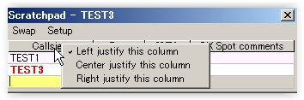

LBEW_41

### 9.6.4 Manual Entry Field Background Color in Scratchpad

This is the same as the Data field background and Data field background (focus) in the Logbook Entry window. In my case White for Data field background and Yellow for Data field background. The manual entry field background color is like this.

Manual entry field (Callsign);

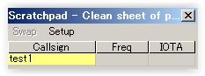

LBEW_42

Moving focus to IOTA field; and,

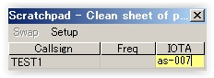

LBEW_43

When Scratchpad loses focus.

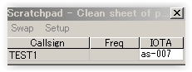

LBEW_44